AWS CLOUD PROJECT

AWS S3 Static Hosting

Prepared by: _____C TRISHA_____________

1. Project overview
Amazon S3 is an object storage service that stores files in buckets. Static website hosting uses S3 to serve website assets such as HTML, CSS, JavaScript, and images directly to a browser. It is suitable for websites that do not require server-side code.

2. Key concepts
- Bucket and objects: the bucket stores the website files, including the home page, commonly named index.html.
- Hosting configuration: static website hosting must be enabled and the index document specified.
- Website endpoint: after configuration, the endpoint is used to open and test the website.
- Access and security: website content should be public only when intended. Review Block Public Access and bucket policies carefully before changing permissions.
- Limitations: S3 static website hosting does not run backend code or databases; dynamic features need a separate service.

3. Implementation workflow
Create a bucket → upload index.html and supporting assets → enable static website hosting → set the index document → configure appropriate access → open the endpoint and test the page.

4. Validation and troubleshooting
- Confirm that index.html and supporting files are uploaded to the expected bucket.
- Check that the index document name matches the uploaded file exactly.
- If the page is inaccessible, review the hosting configuration, endpoint, and permissions.
- If the page loads without styling or images, check the file paths and upload the missing assets.

5. Security considerations
Only publish files that are intended for public access. Avoid uploading credentials, personal information, or confidential data. For production websites requiring HTTPS, custom domains, and edge caching, consider using Amazon CloudFront with S3.

What I Learned
Through this project, I gained a better understanding of how Amazon S3 can be used not only as a cloud storage service but also as a simple and cost-effective solution for hosting static websites. I learned that a website can be published by storing its HTML, CSS, JavaScript, and image files in an S3 bucket, without the need to maintain a traditional web server.
I understood the importance of organizing website files correctly, especially ensuring that the main page, such as index.html, is uploaded and configured as the index document. I also learned that enabling static website hosting and accessing the correct website endpoint are essential steps in making the website available to visitors.
Another important learning was the role of security in cloud hosting. I understood that website accessibility must be balanced with appropriate access controls. Public access should be enabled only when the website is intended for public viewing, while confidential files and sensitive information must remain protected. Reviewing S3 Block Public Access settings and bucket policies is therefore an important part of responsible cloud configuration.
I also learned the value of testing and troubleshooting after deployment. Verifying the website endpoint, checking that all supporting files load correctly, and reviewing permissions help identify configuration issues and ensure that the website behaves as expected.
Overall, this project helped me understand the practical benefits of cloud-based website hosting, including scalability, reduced server maintenance, and straightforward integration with other AWS services. It strengthened my knowledge of Amazon S3, basic website deployment, cloud security, and the importance of validating each configuration step. I now have a clearer understanding of how cloud services can be used to deploy and manage web content efficiently while following good security practices.

Practical evidence to attach
Insert your own screenshots from the actual project in the spaces below. No screenshots from previous assignments have been copied into this report.
Screenshot 1: S3 bucket showing the uploaded website files (for example, index.html and CSS/assets).
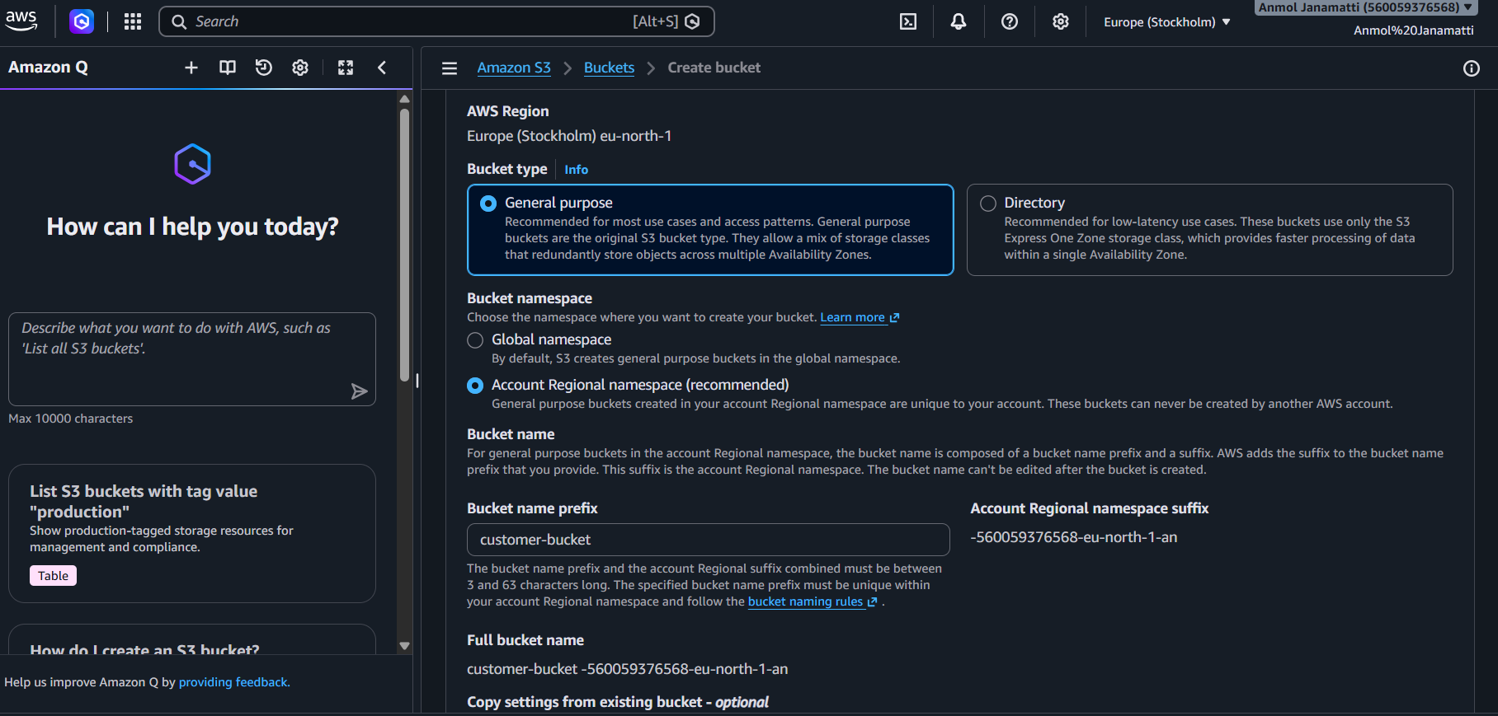
Screenshot 2: Bucket Properties page showing Static website hosting enabled and the index document.
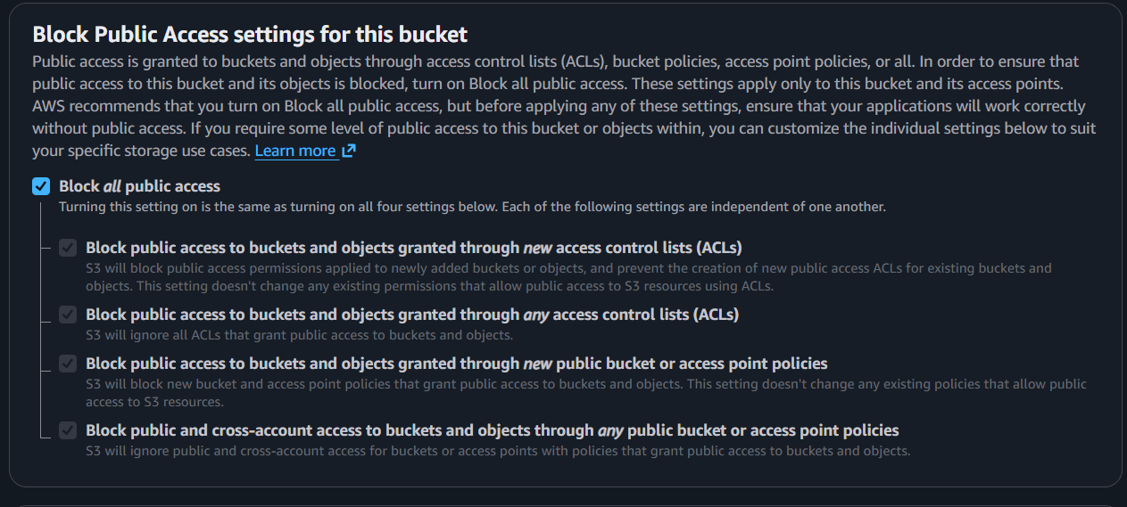
Screenshot 3: Website endpoint opened in a browser, showing the rendered website.
